CS 255 System Design Document Template

UML Diagrams

UML Use Case Diagram
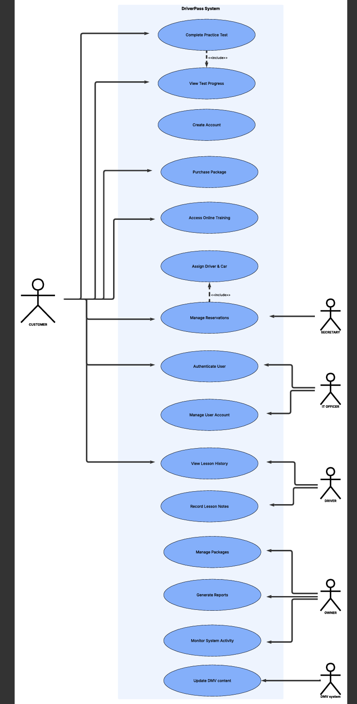

UML Activity Diagrams
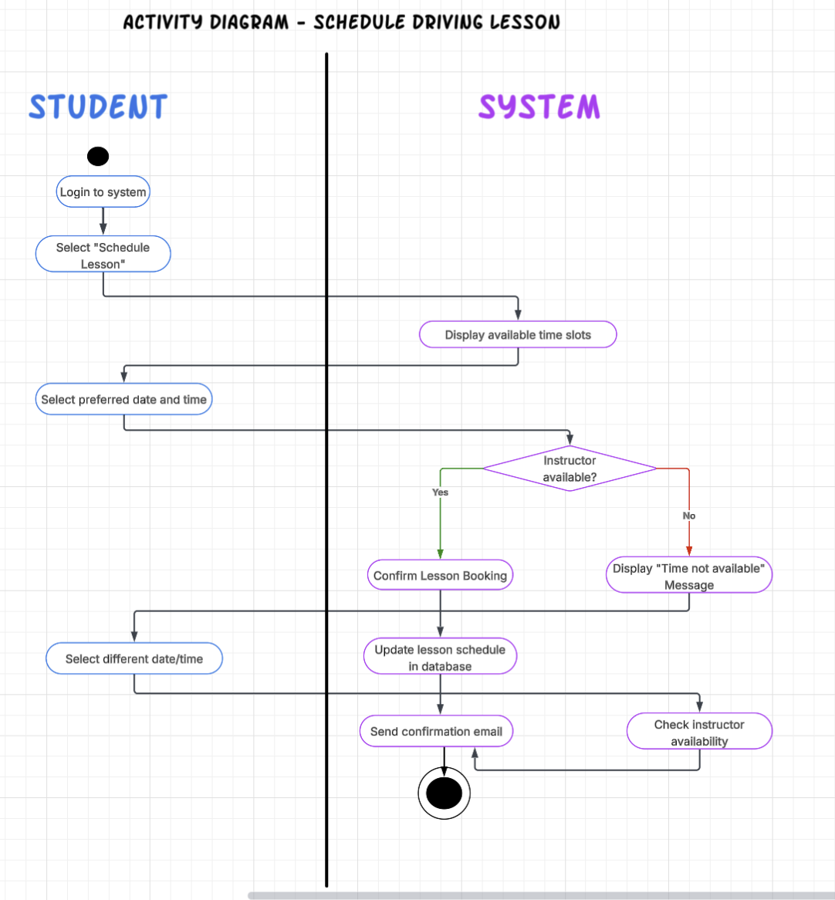

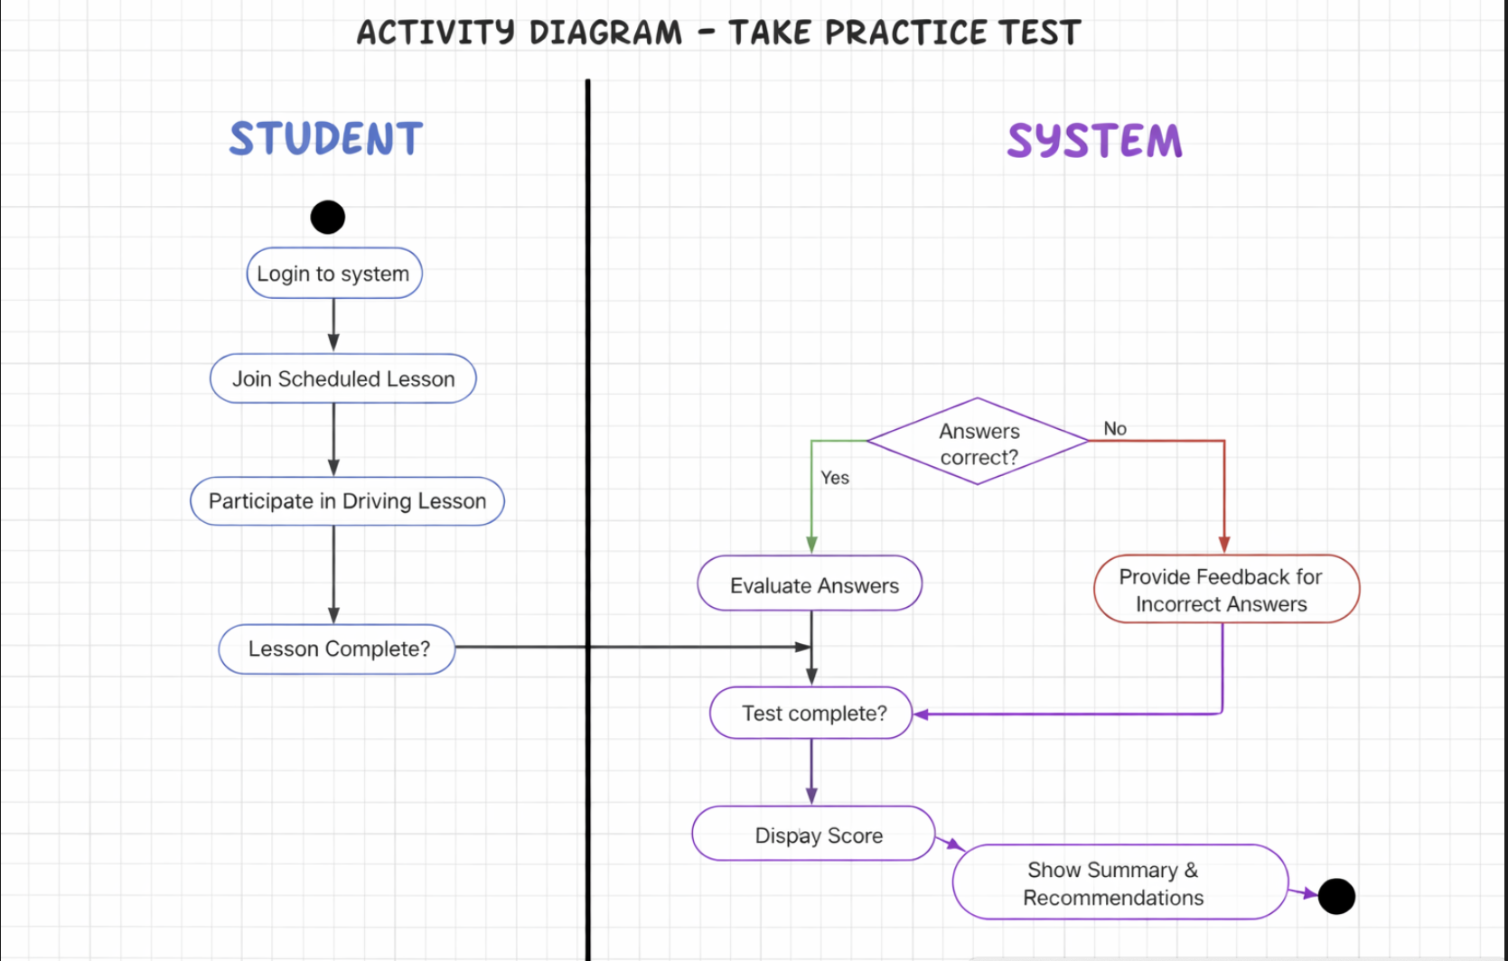

UML Sequence Diagram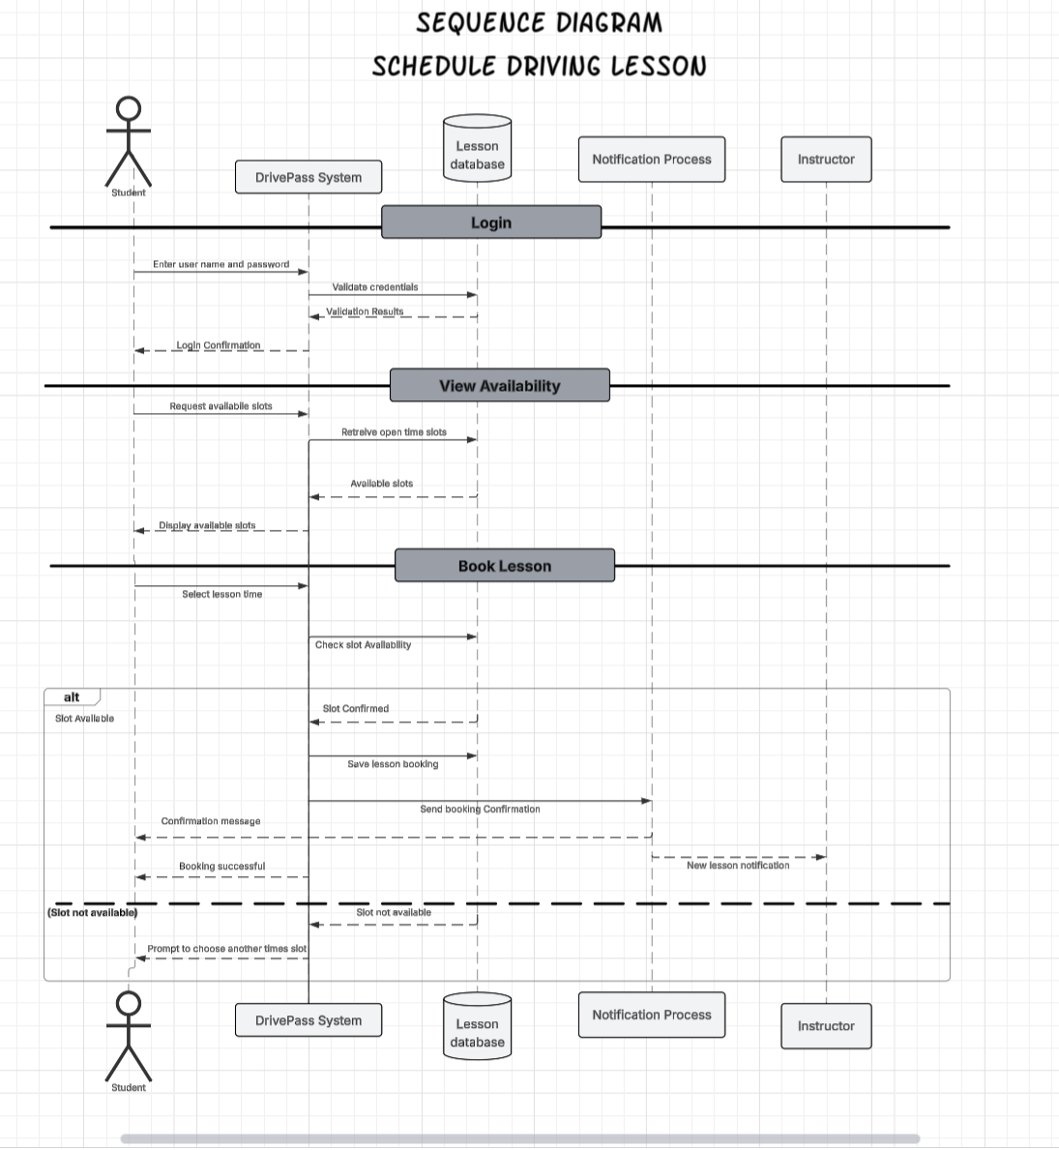

UML Class Diagram
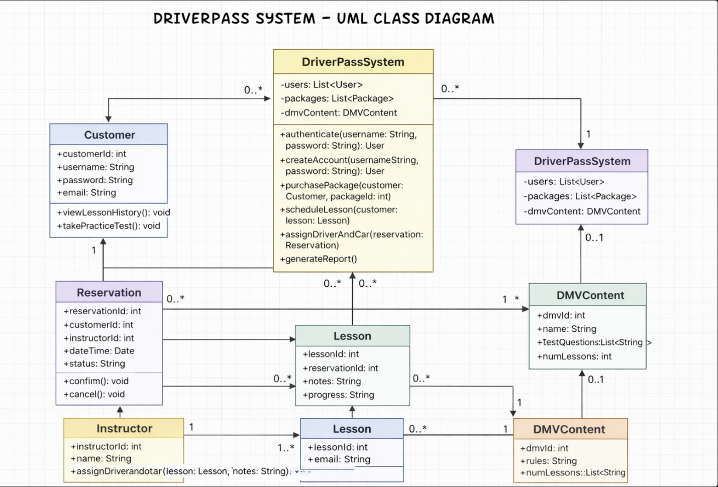

Technical Requirements
1. Hardware Requirements
For Customers and Staff:
- Desktop or laptop computer
- Smartphone or tablet (to support mobile access)
- Reliable internet connection
For Business:
- Application server
- Database server
- Backup storage device or cloud-based backup solution
2. Software Requirements
Application Software:
- Web-based application (front-end and back-end)
- Secure login and authentication system
- Online scheduling module
- Practice test engine with scoring logic
- Reporting and administrative dashboard
- Email notification system
Database Software:
- Relational database management system
- Secure storage for: User accounts, Lesson schedules, Instructor assignments, Practice test questions, Lesson notes, and progress records
Operating Systems:
- Server OS (Windows Server or Linux-based system)
- End-user devices
3. Development Tools
To build and maintain the system:
- Programming language for back-end development (such as Java, Python, or C#)
- Front-end technologies (HTML, CSS, JavaScript)
- Database management tools
- Version control system
- Testing tools for validating scheduling, login security, and scoring logic
- UML modeling tools for system documentation and updates
4. Infrastructure Requirements
Hosting:
- Cloud hosting provider (scalability and reliability)
- Secure web server (HTTPS enabled)
Security:
- SSL/TLS encryption
- Password hashing and secure authentication
- Role-based access control (students, instructors, admin, owner)
- Regular system backups
- Firewall and network security monitoring
Integration:
- Email service provider for confirmation emails
- Updated DMV content integration to ensure practice tests remain accurate

DriverPass works on computers, tablets, and smartphones that connect to the internet. It has a secure web application that makes it easy to manage and access data.
DriverPass is hosted in the cloud, and users can access it from anywhere with an internet connection. It uses strong security measures, like encryption and multi-factor authentication, to protect personal information.
DriverPass offers important features to help users learn to drive. Users can book lessons online whenever they want. They can take practice tests to prepare for their exams and use a tool to track their progress through the lessons. The platform provides clear performance reports, and it keeps user accounts secure.

